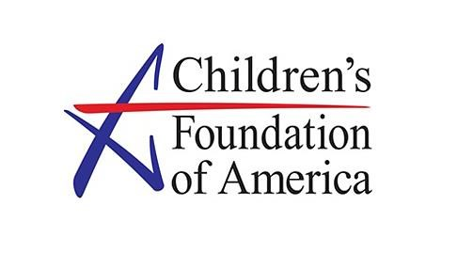

**Volunteer Waiver**

By signing this agreement, I am applying to perform certain volunteer services related to a **Children's Foundation of America Event**. I acknowledge that my participation is completely voluntary on my part and is being undertaken without promise or expectation of compensation.

**Disclaimer:** In consideration of being allowed to participate in the volunteer community service event, I hereby release and discharge The Children’s Foundation of America, its affiliates, associates, agents and any participating organizations for any claims for damages or injury I may incur resulting from my contributions to this event. I further state that I am and/or my child(ren) is (are) in proper condition for helping with these events. I agree to abide by the rules established by the organizers of this service project relating to both the health and safety requirements. Finally, *per my response below*, I grant The Children’s Foundation of America full and complete permission to use photographs and quotes from me for future project promotions.

|  |
| --- |
| **Volunteer Printed Name:** |
| **Volunteer Signature:** |
| **Date:** |

**For volunteers under the age of 18: I hereby agree and consent to the forgoing terms:**

|  |
| --- |
| **Parent/Legal Guardian Printed Name:** |
| **Parent/Legal Guardian Signature:** |
| **Emergency Contact Number:** |
| **Date:** |